Freight Rate Prediction
Machine Learning Engineer Assessment for Spotter

1. Overview
I used train-test.csv as the development dataset and built a regression model to predict posted_rate. The workflow was to inspect the data, handle missing values, create date features, compare two models, choose the better model on a holdout set, and then train it on the full development data for the final predictions.

2. Data exploration and cleaning
The development data contains 48,000 rows and 14 columns. There were 300 missing values in weight and 374 missing values in market_index. I kept these rows and handled missing numerical values with median imputation during preprocessing.
Pickup, delivery, and equipment were treated as categorical variables and one-hot encoded. The date column was converted to datetime and month and day of week were extracted. load_id was not used as a feature.

3. Features and model
The numerical features were pickup/delivery coordinates, distance, weight, market_index, quote_signal, month, and day of week. The categorical features were pickup, delivery, and equipment.
I compared Random Forest and Gradient Boosting using the same 80/20 random split. Gradient Boosting performed noticeably better.
Model | MAE | RMSE | R²
Random Forest | 130.77 | 568.85 | 0.8487
Gradient Boosting | 108.25 | 530.91 | 0.8682

The selected Gradient Boosting model used 100 estimators, learning_rate=0.1, max_depth=3, and random_state=42.

4. Train/validation split
For the main evaluation I used an 80/20 random split with random_state=42. Preprocessing was kept inside the model pipeline.
I also checked a chronological 80/20 split as a sanity check. It produced MAE 118.12, RMSE 632.90, and R² 0.8274. This was worse than the random split, suggesting some change in performance over time. I kept the random split as the primary evaluation.

5. Final validation predictions
After selecting Gradient Boosting, I retrained it on all 48,000 development rows and predicted all 12,000 rows in validation.csv. The resulting validation_predictions.csv contains load_id and predicted_rate.

6. December scenario
The December input contains fewer fields than the development data, so I used a compatible feature subset: pickup, delivery, distance, equipment, weight, month, and day of week. This produced one prediction for each of the 31 December dates.
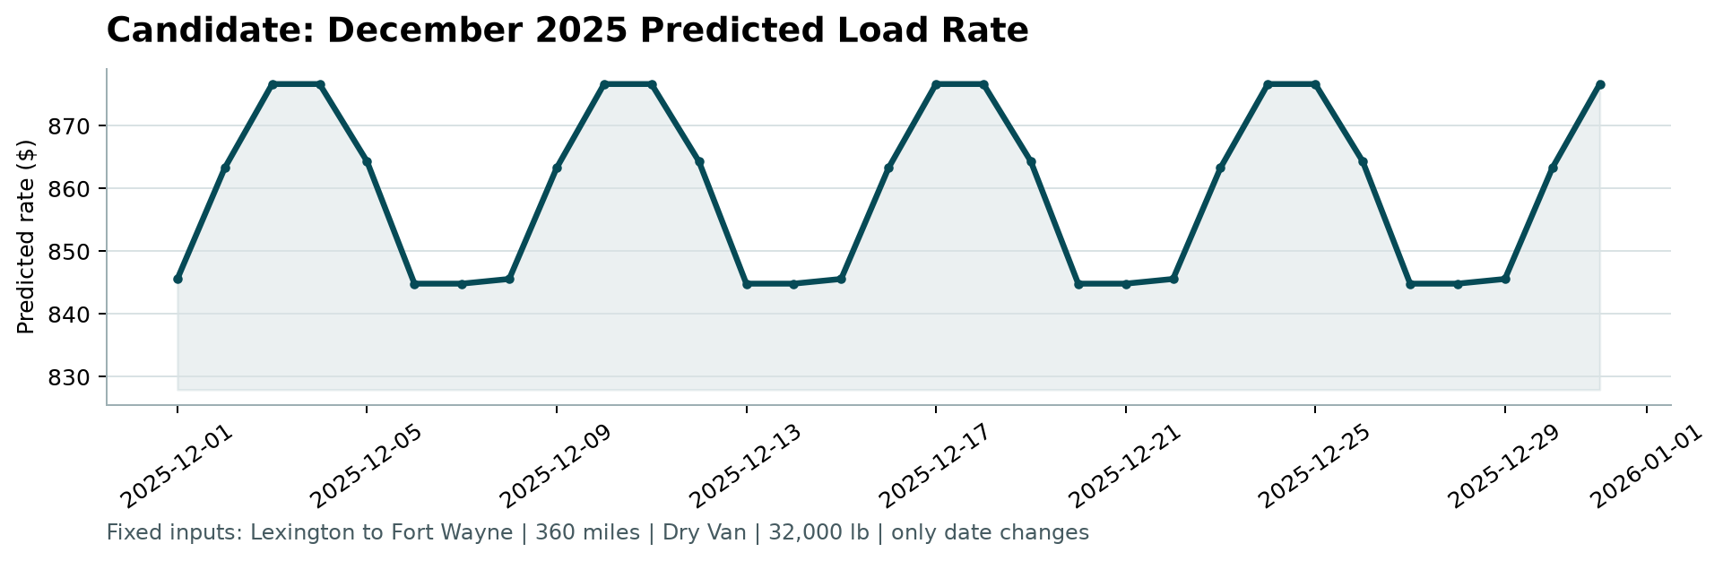
December 2025 fixed-scenario predictions

7. Final checks
I ran the provided score.py against validation_predictions.csv and december_predictions.csv. The scorer accepted both files and generated the December chart.

